M3 — Parametric Furniture [m3.gh](https://drive.google.com/file/d/1Mjavb39pCGJKTULN5ck4MmSpb4MIX1q8/view?usp=drive_link)

Once again, using the built-in Rhino plug-in, Grasshopper, this final mini-assignment was mainly an introduction to 3D printer fabrication, as well as good practice creating parameterized designs in Grasshopper, and in baking geometry/interfacing between software(s) and fabrication.

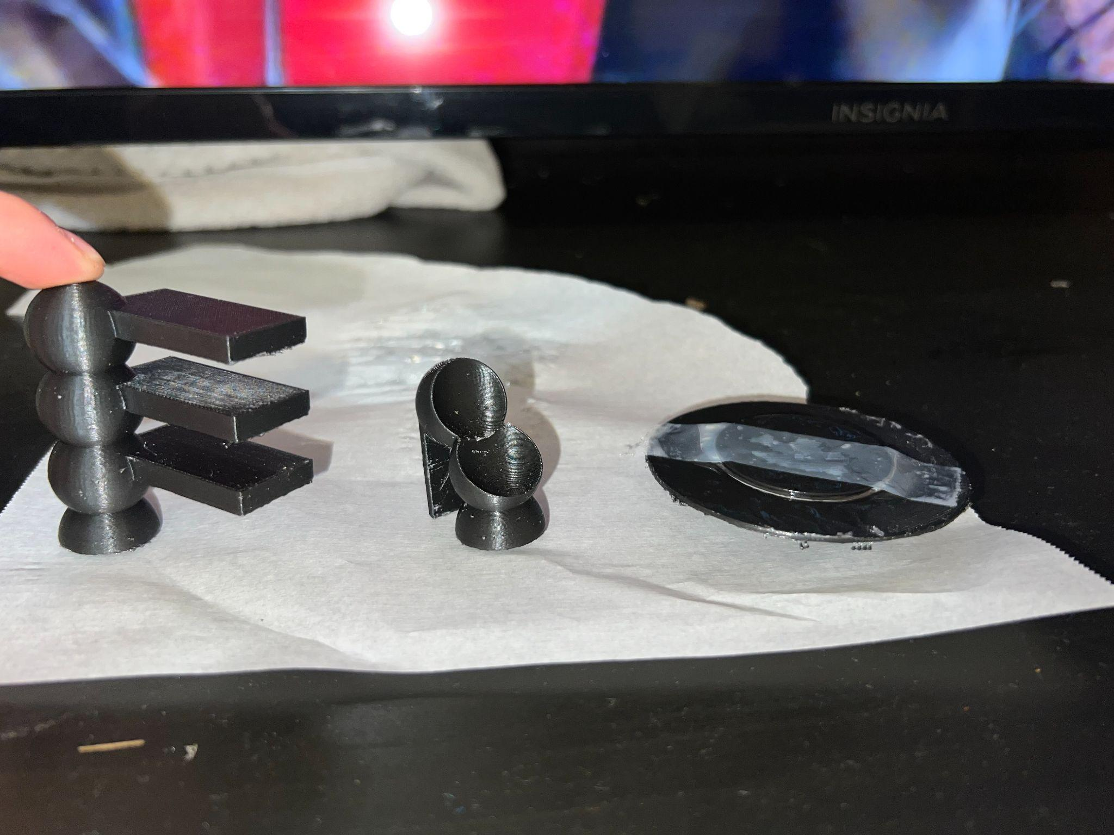

Materials Used

* PLA

Math Used

* Geometry (areas, volumes, centroids…)
* Cartesian coordinates (points, lines…)

Task #1

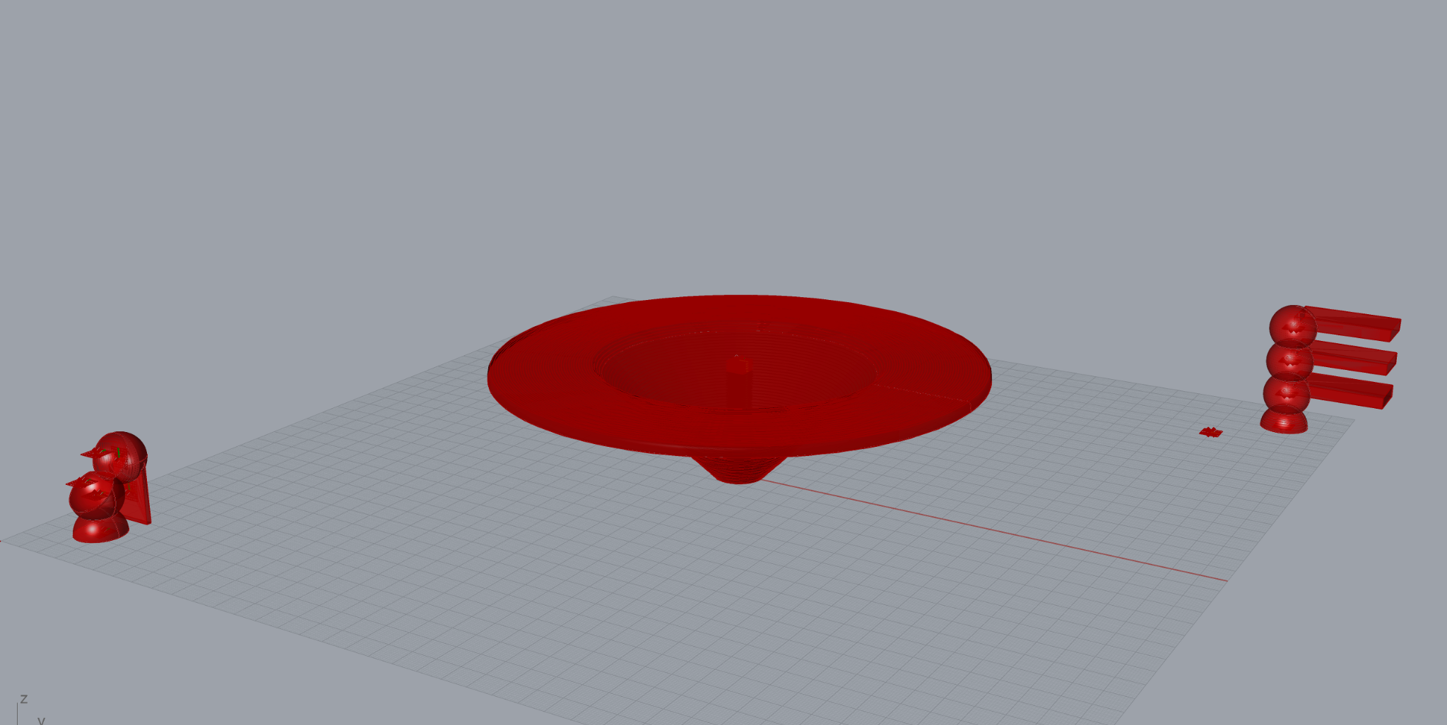

Task one set me on a quest to think of interesting household objects to design. Inevitably, I decided on basic furniture—a table, a standing shelf (that does not stand), and a chair—redesigned with the power of Grasshopper. I ended up using spheres quite a bit, in both the shelf and the chair, extremely pleased with the visual look of them stacked, as well as the results they produce when solid tools are applied (union, difference, intersection). Both together, as well as with other shapes, like the actual shelves, the combinations of solids culminated in unique results. For the table, I settled on an inverted-cone look with the tabletop itself forming a ring around. Initially, the center of the table was going to be left open, however, I ended up adding a recessed surface in the middle to give more area to the top. Overall, I had quite a bit of fun experimenting more with the solid tools and in creating these mini-furniture pieces. Below is the visual code for the table, shelf, and chair, respectively:

Table

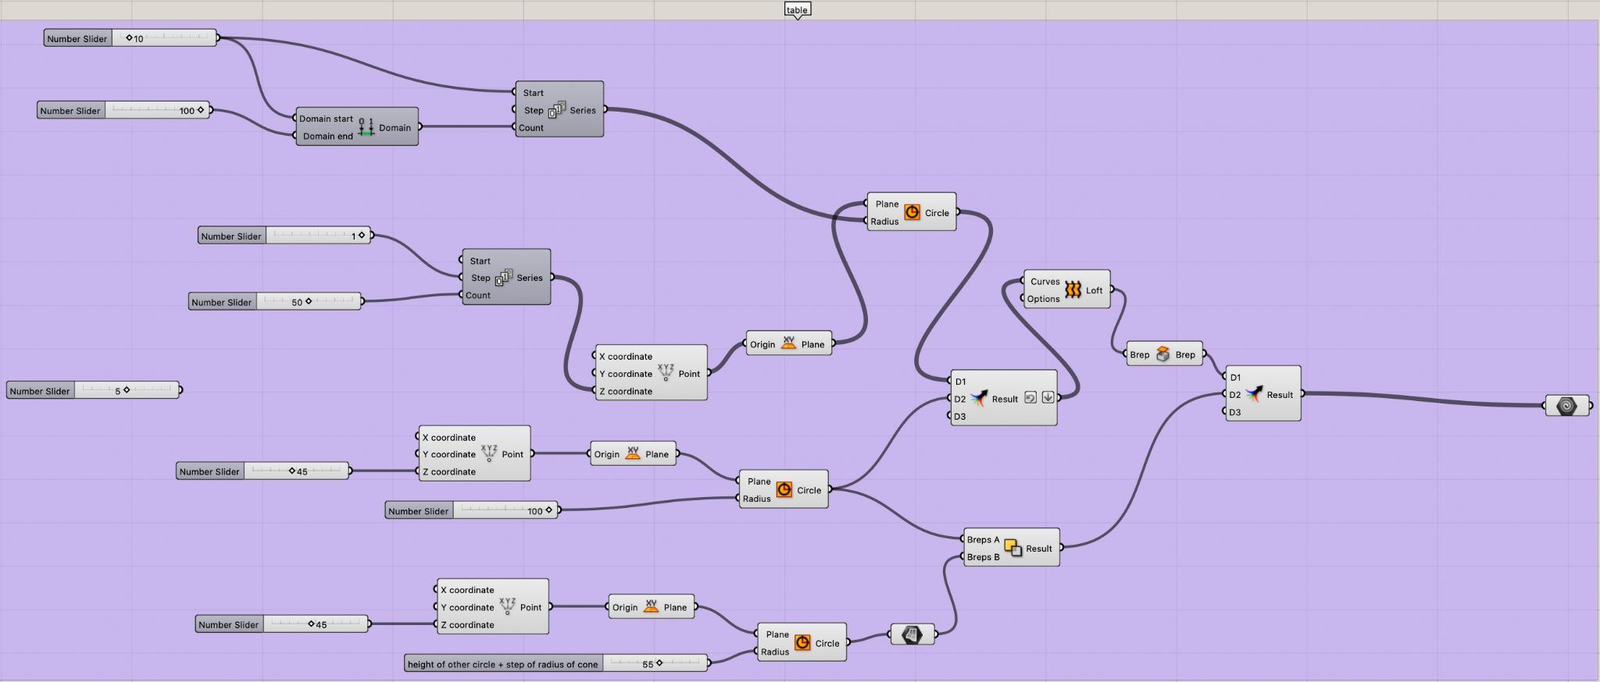

Shelf

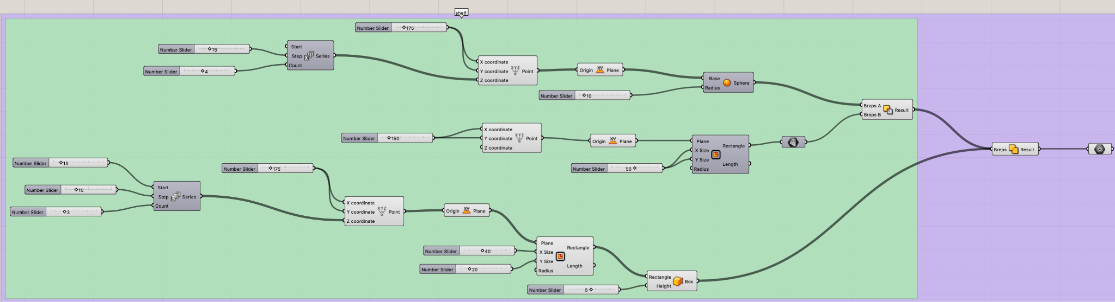

Chair

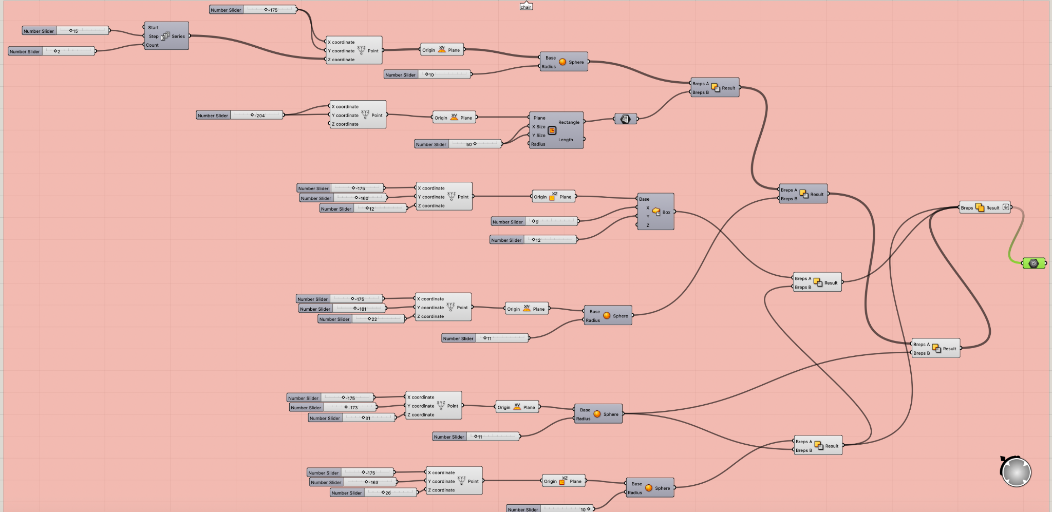

Task #2

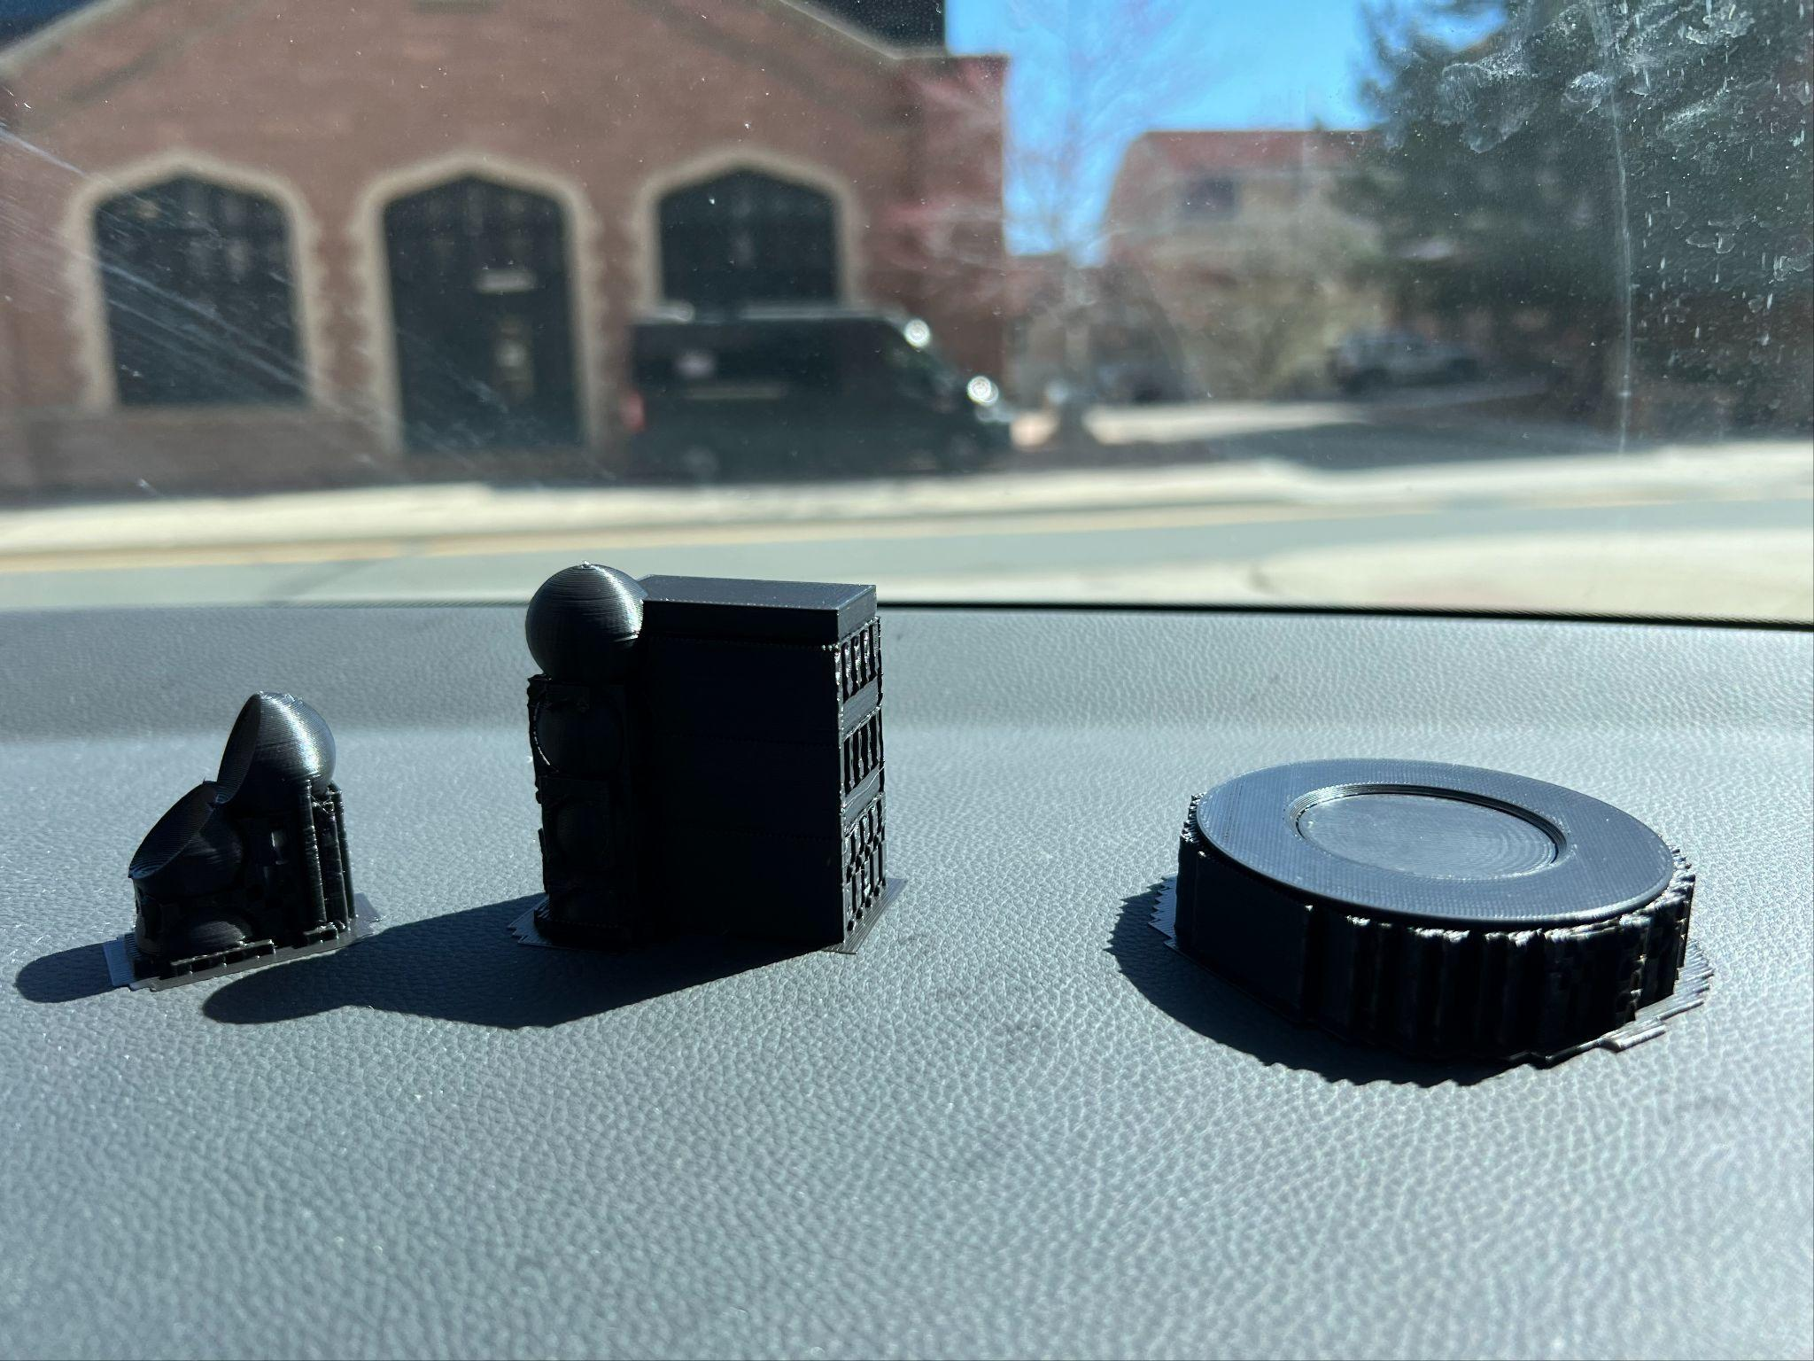

Task two was to simply 3D print our parameterized furniture designs. Given my previous use with the 3D printers this was not too big of a task to tackle, and I was quite pleased with how they turned out. They were printed on the Prusa Mark3 with black PLA filament. The only issue I ran into was the tabletop ring breaking off from the base. Although this is an easy glue-up with hot glue, I was disappointed I had failed to account for the thickness of the recessed tabletop, affecting how well the base and the ring were attached.

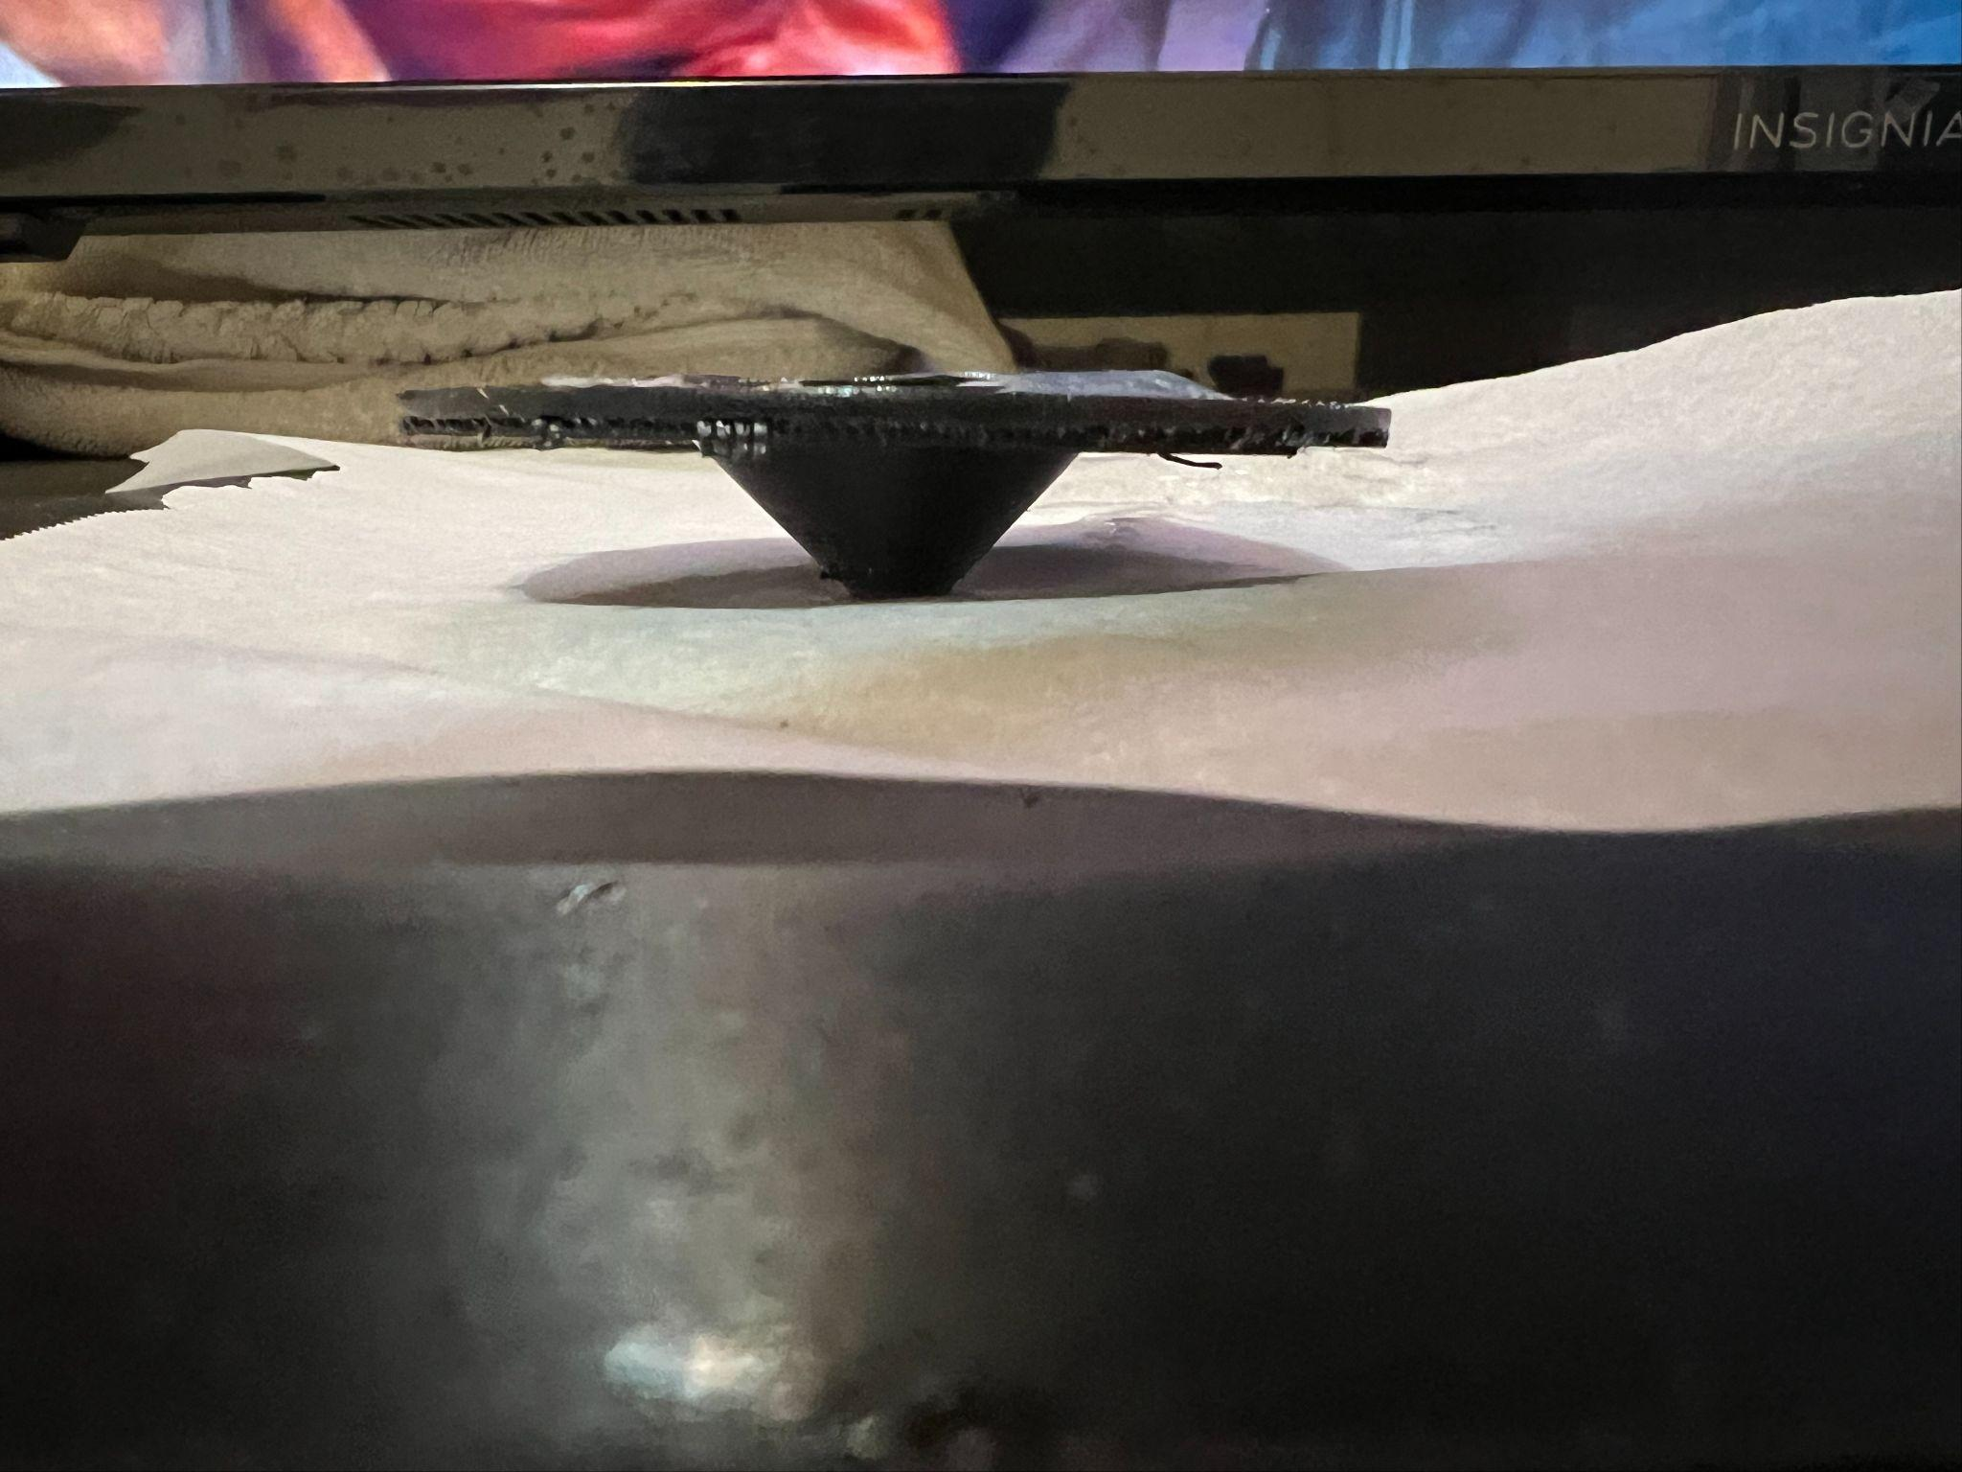

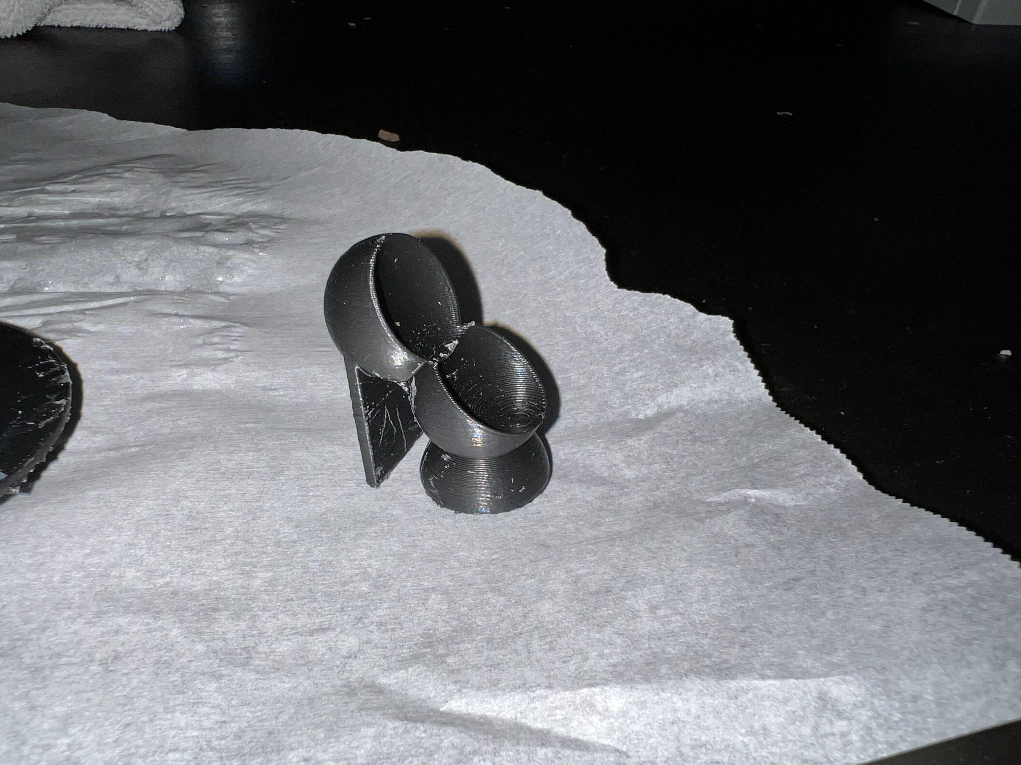

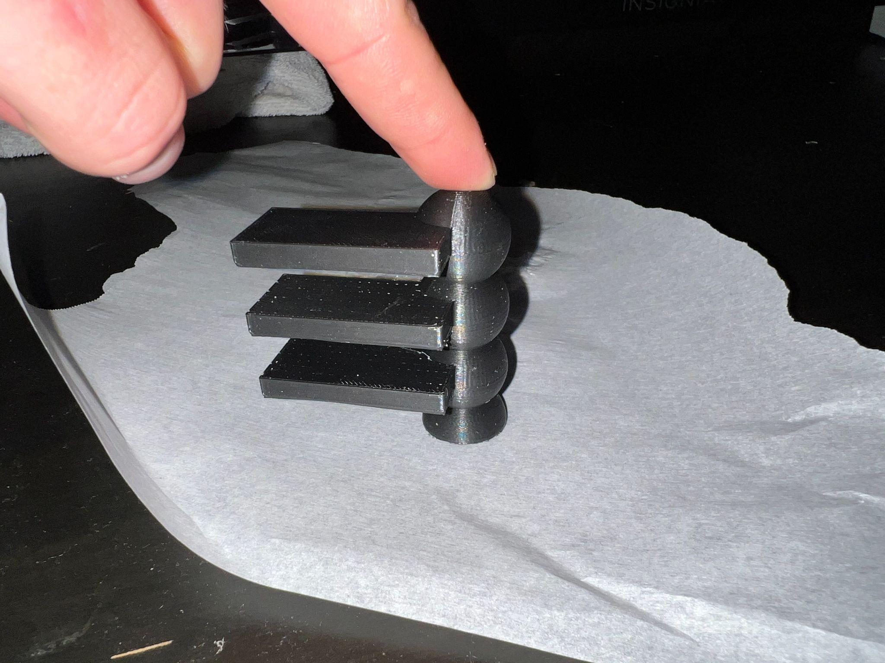

Problems/Conclusion

In conclusion, I found no real pain points as I moved through this project. Rather, it was a good excuse to do some creative work with Grasshopper, and good practice in 3D printer fabrication.